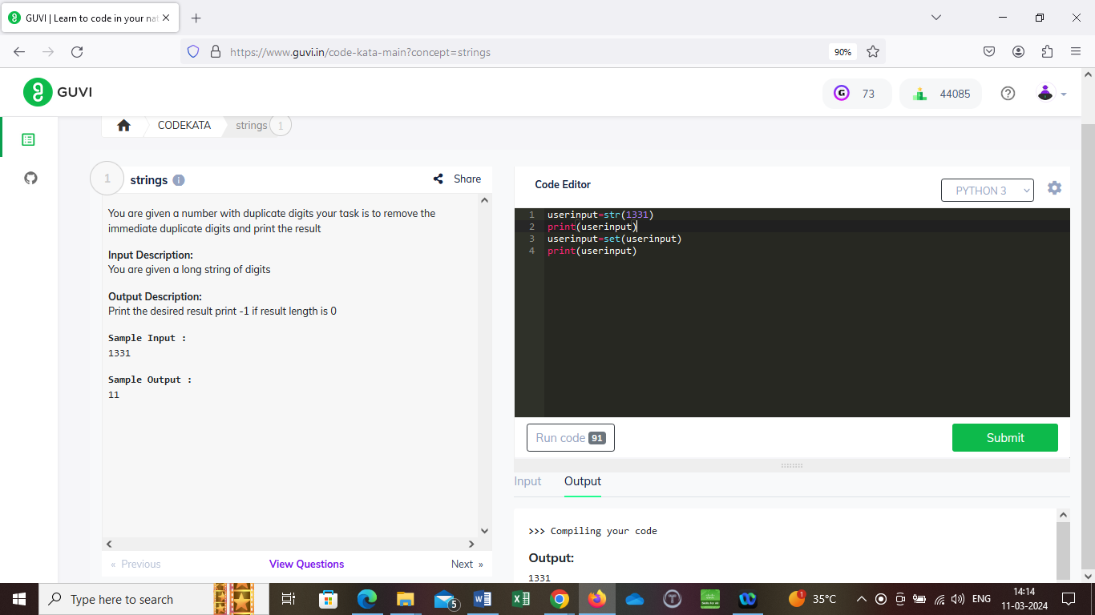

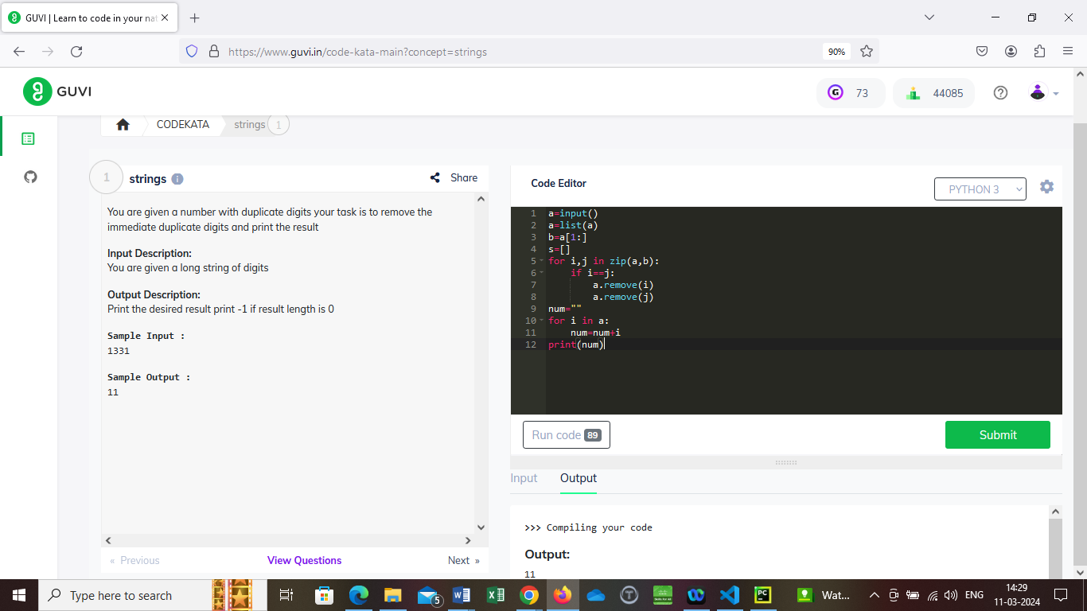

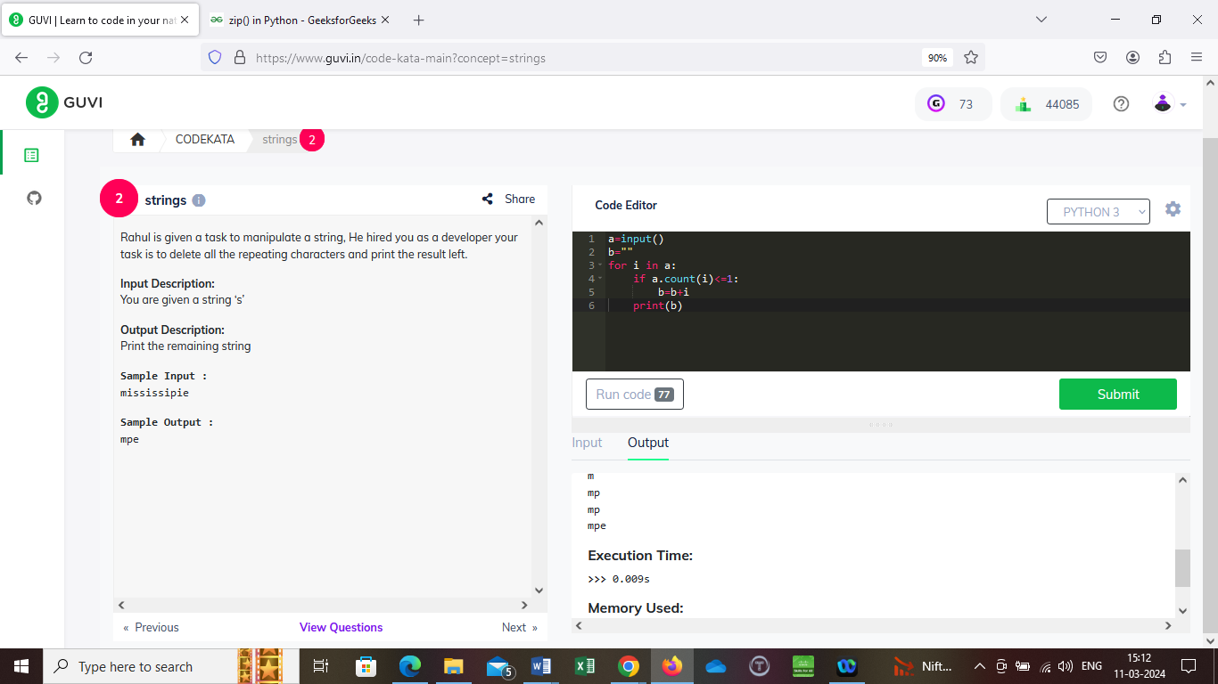

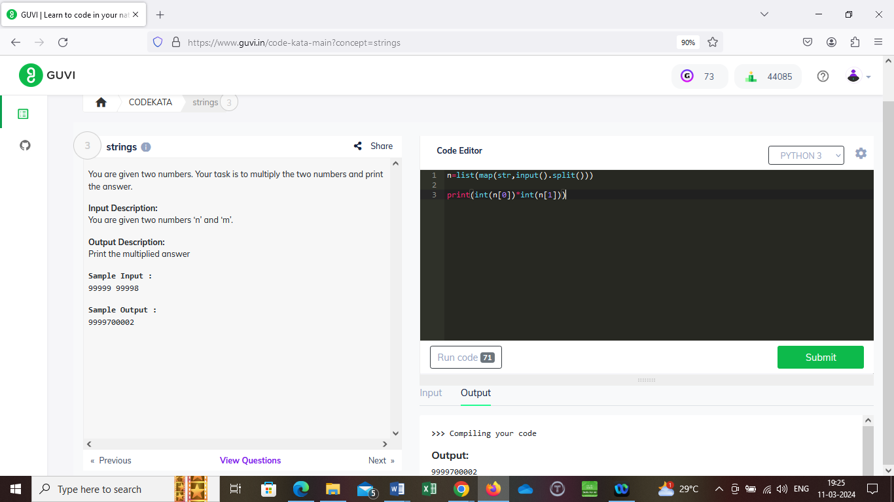

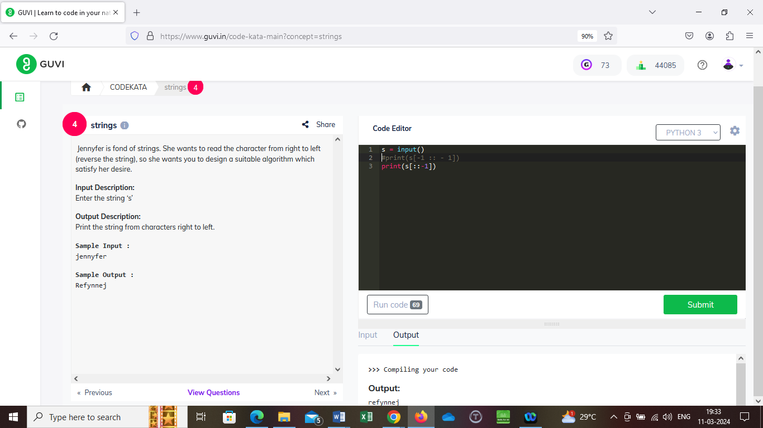

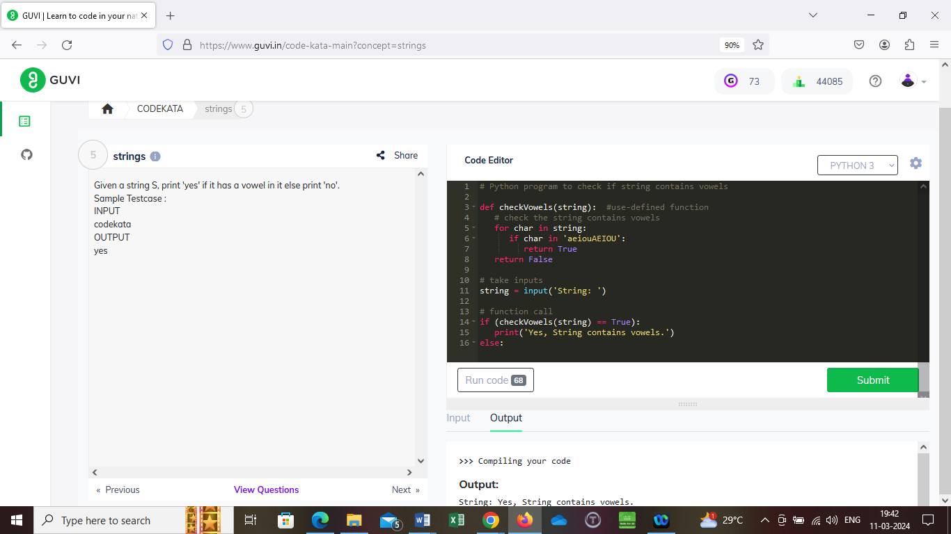

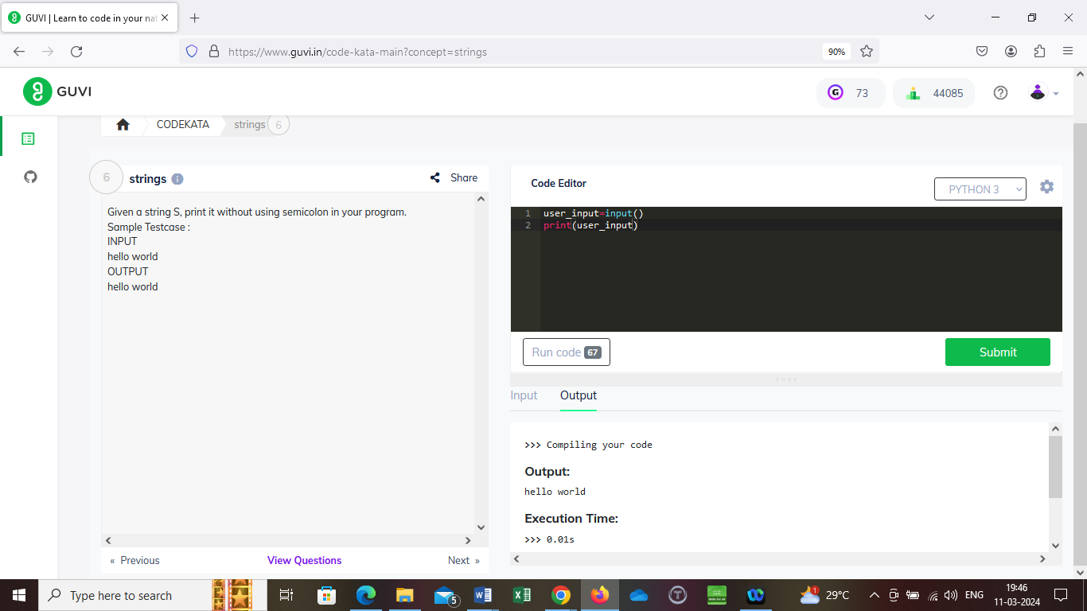

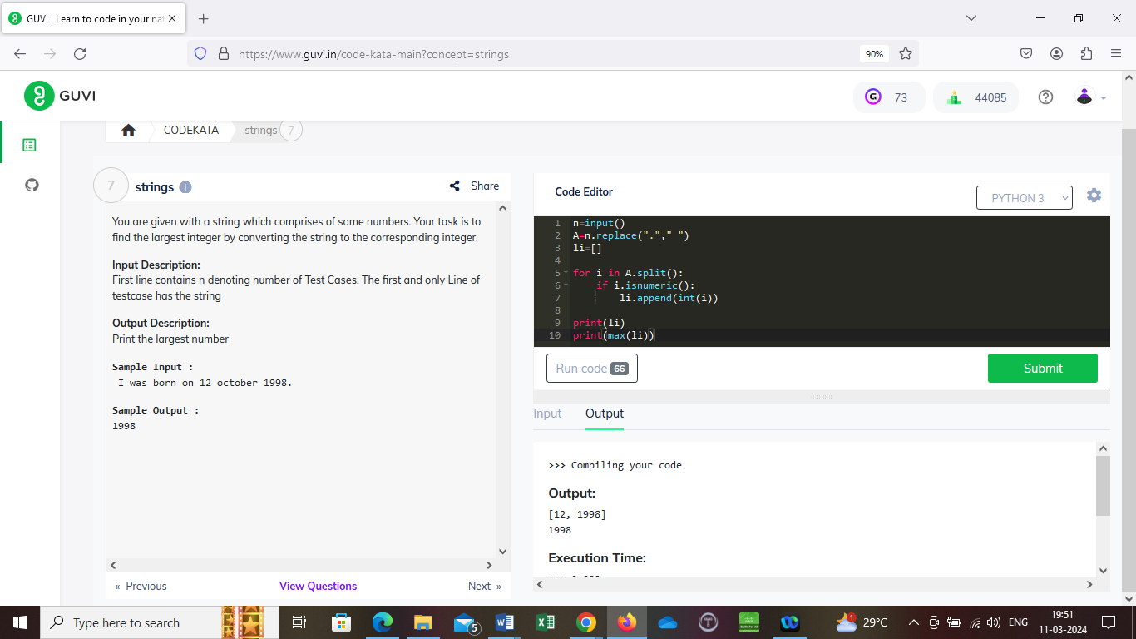

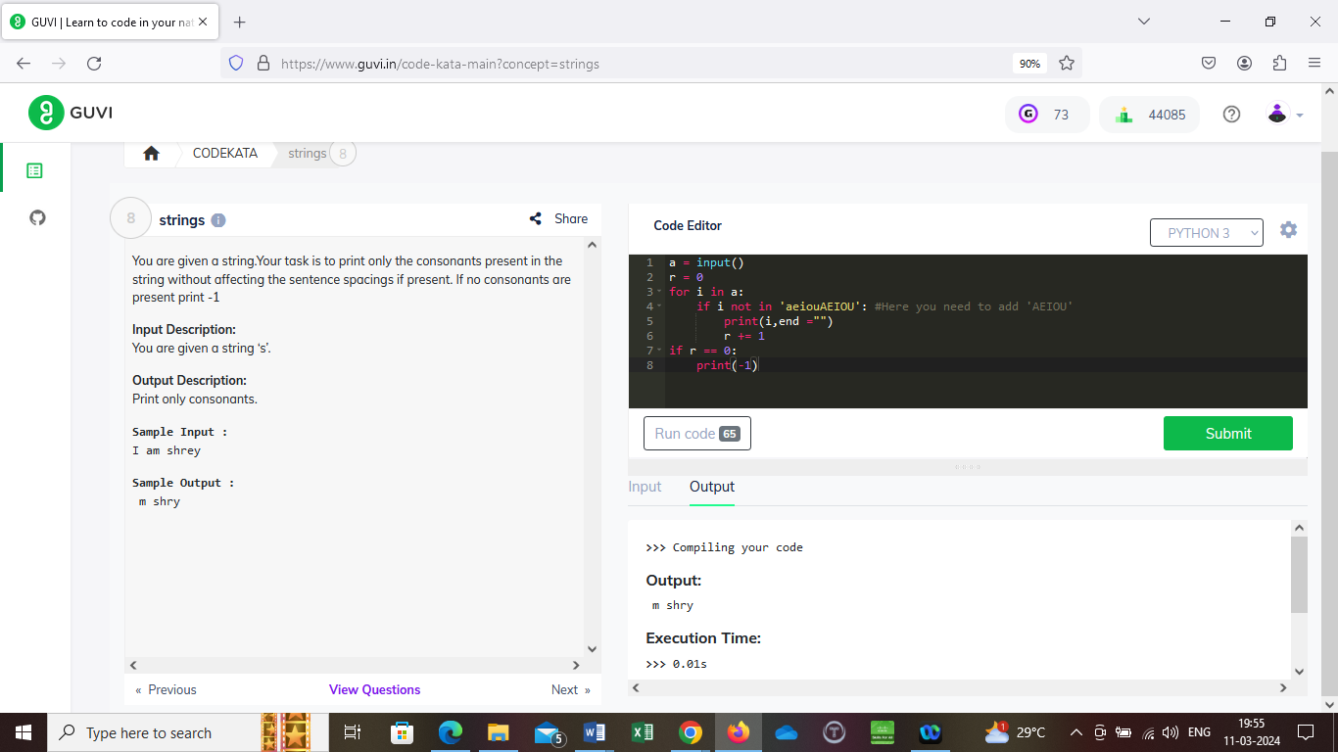

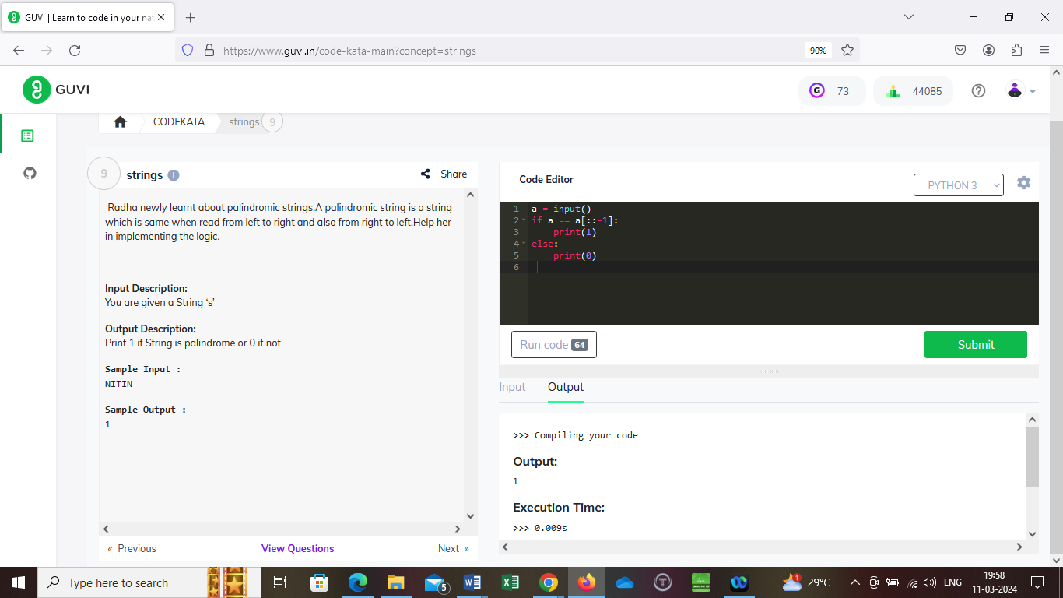

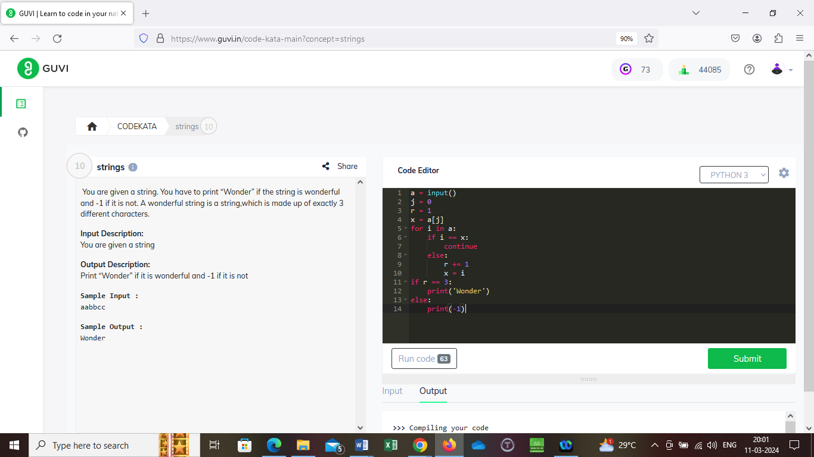

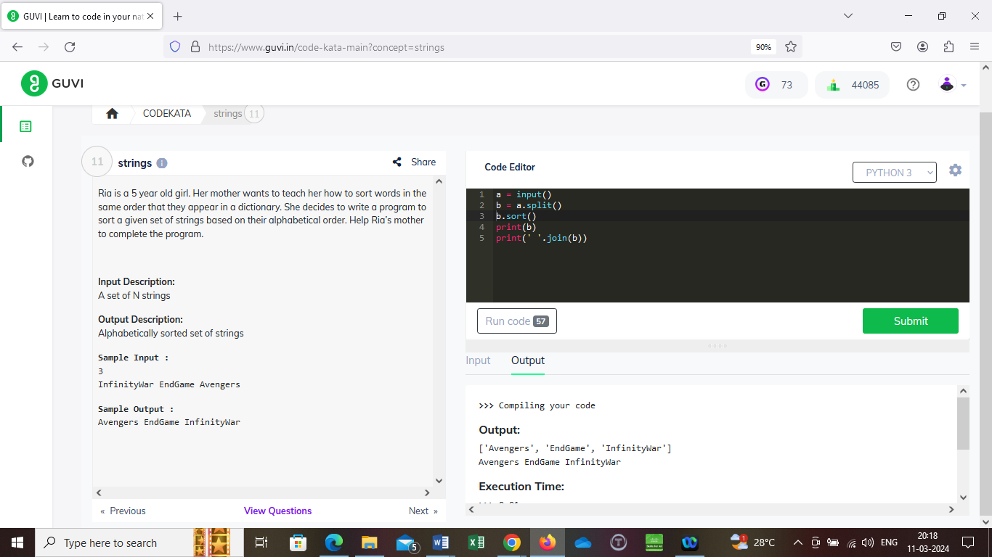

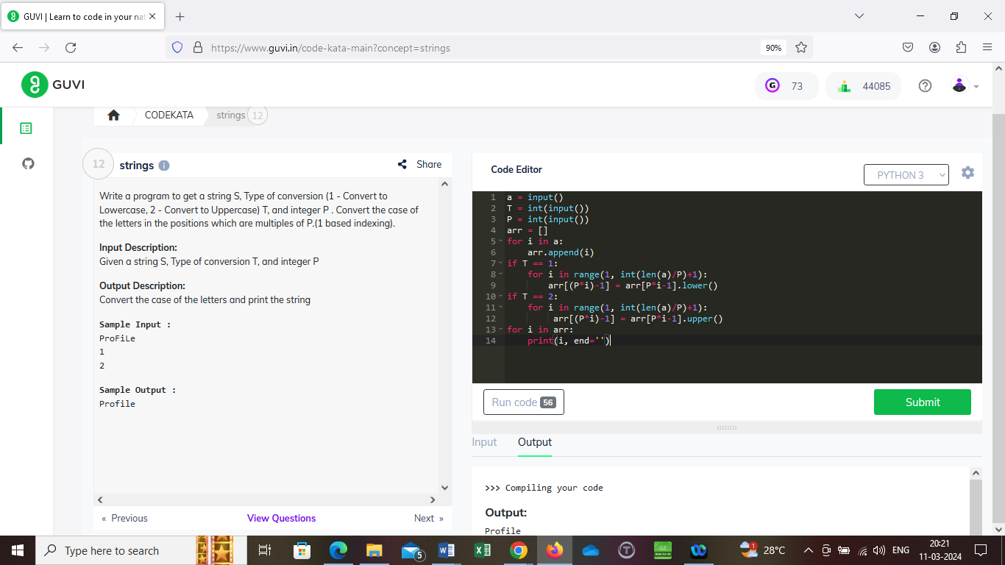

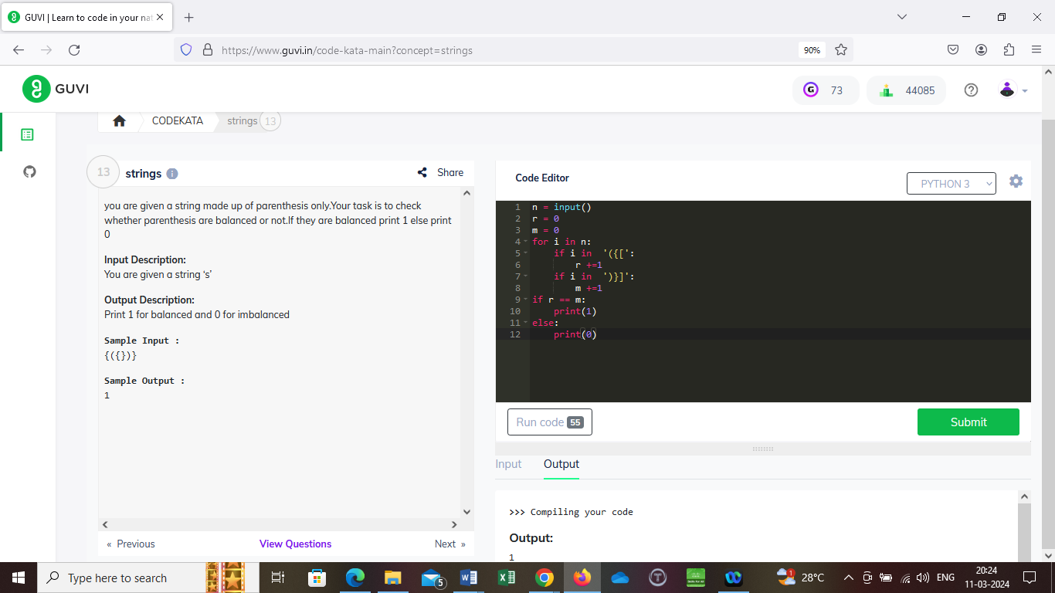

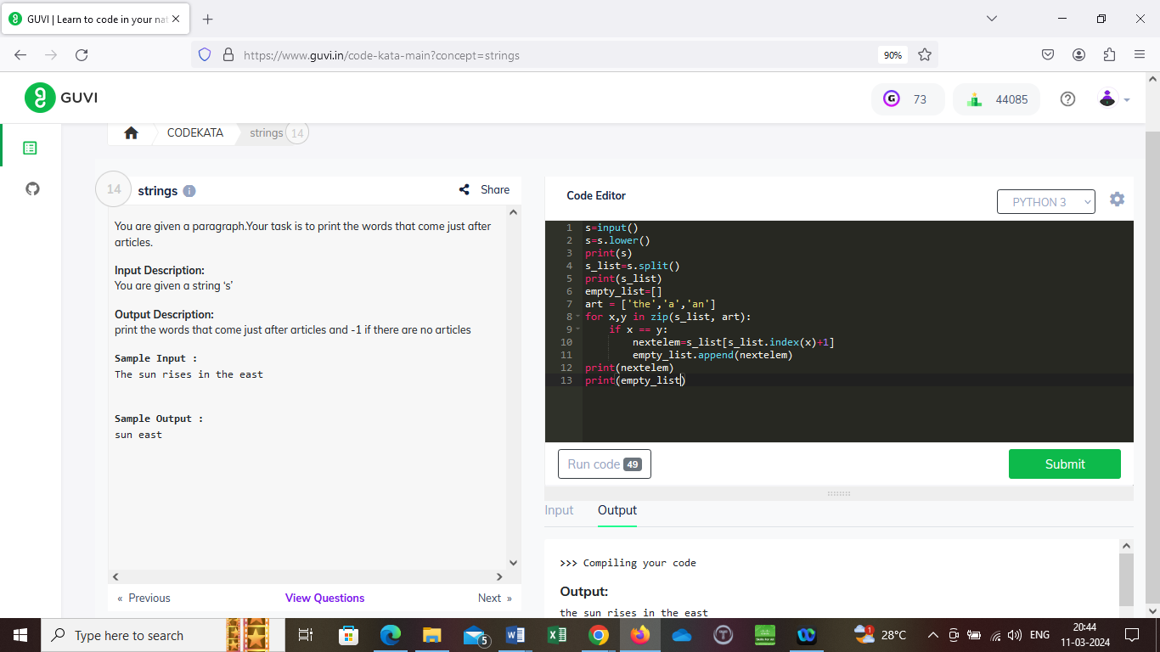

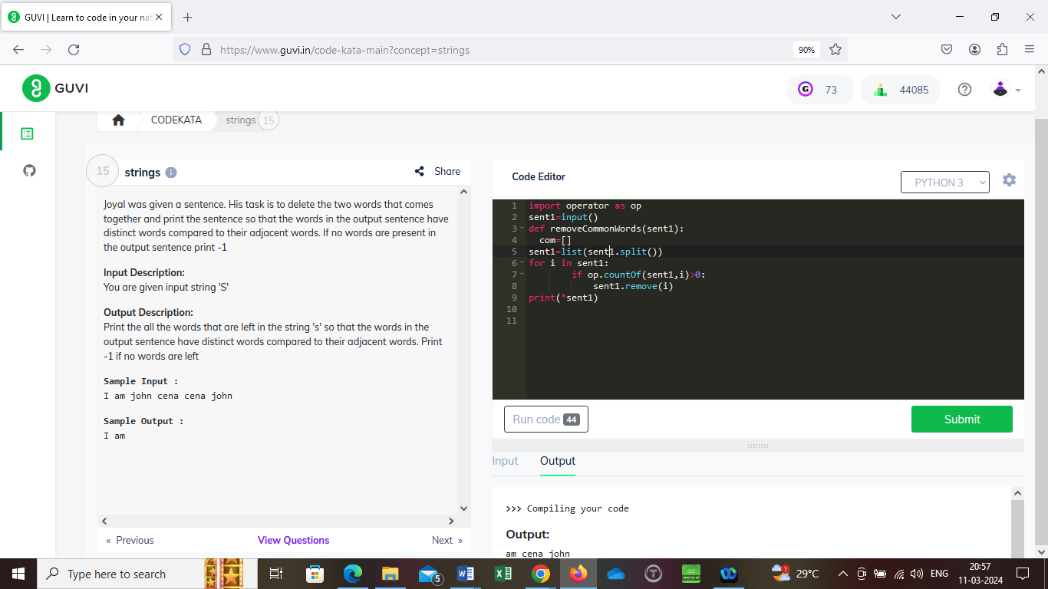

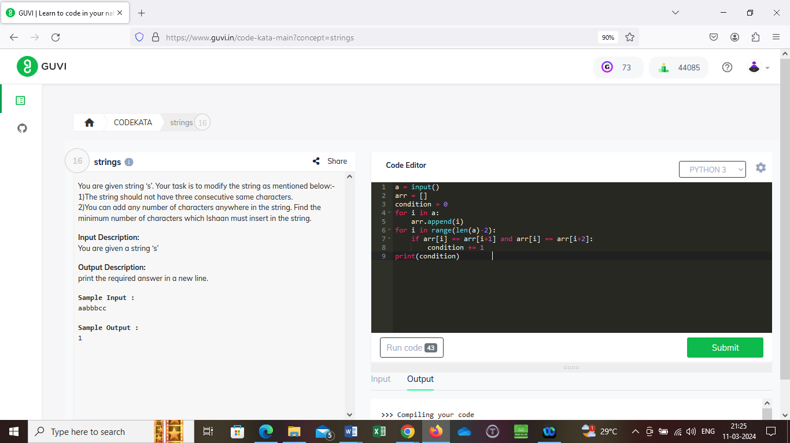

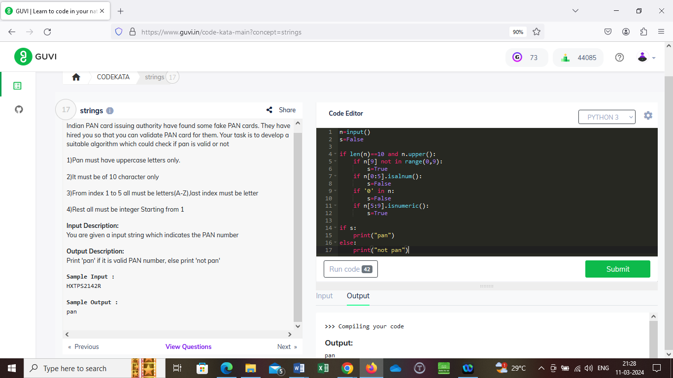

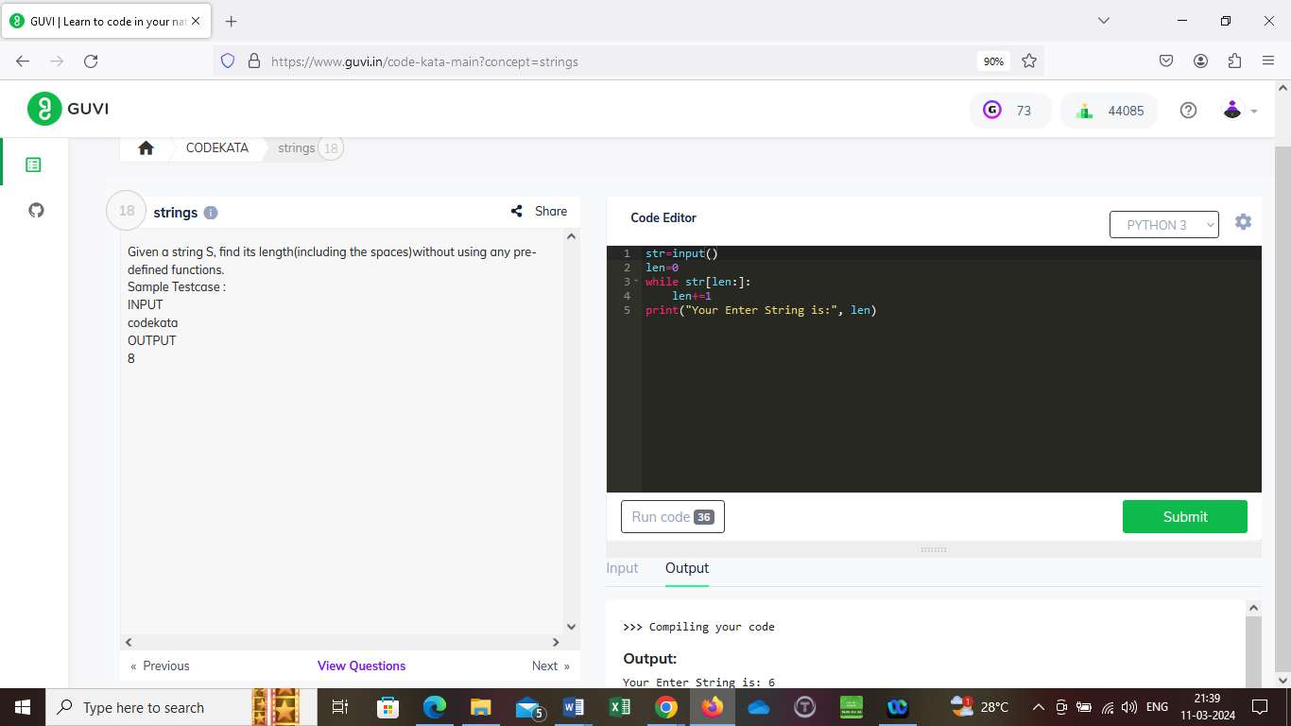

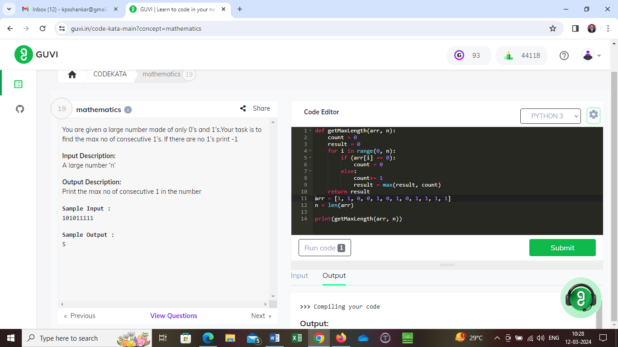

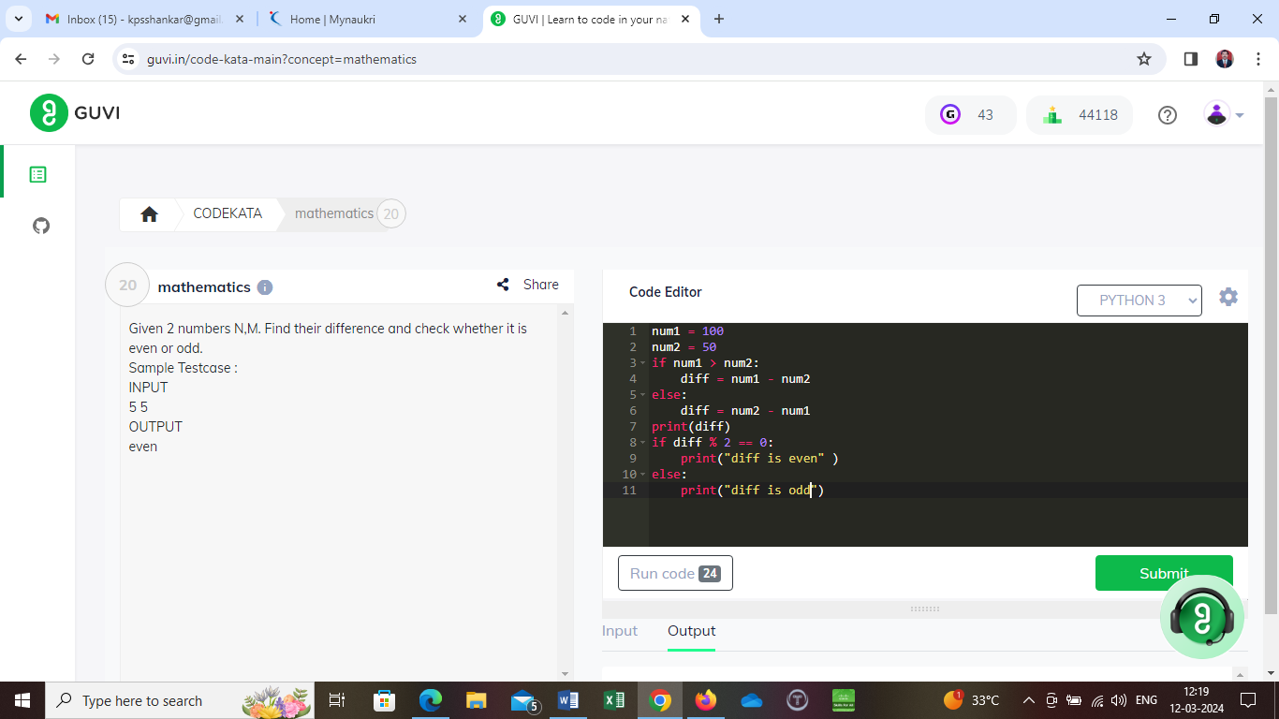

Given a number N, print 'yes' if it is composite else print 'no'.

Sample Testcase

INPUT

123

OUTPUT

yes

N=int(input())

count=0

for i in range(2,N):

if N%i==0:

count=count+1

if count>=1:

print('yes')

else:

print('no')

Given a number N, find the nearest greater multiple of 10.

Input Size : N <= 10000

Sample Testcase :

INPUT

3

OUTPUT

10

import math

number=int(input())

number = number / 10

#ceil is used to round the float value to greatest integer, floor gives the round of lowest value

number =math.ceil(number)

number = number \* 10

print(number)

Given a number N, print the odd digits in the number(space seperated) or print -1 if there is no odd digit in the given number.

Input Size : N <= 100000

Sample Testcase :

INPUT

2143

OUTPUT

1 3

no=int(input())

ls=[]

for i in range(len(str(no))):

digit=no%10

if digit%2!=0:

ls.append(digit)

no=no//10

if not ls:

print("-1")

else:

ls.reverse()

print(\*ls,sep=" ")

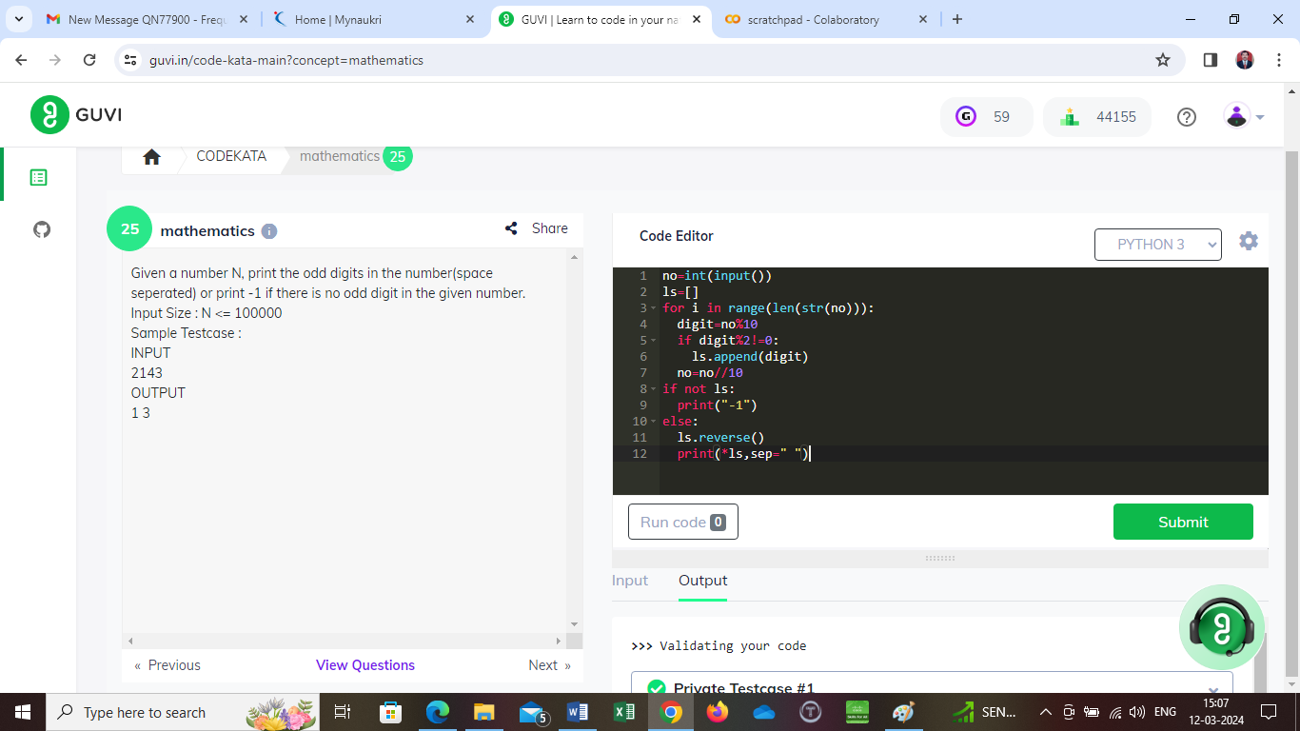

Given 2 numbers N,M. Print 'yes' if their product is a perfect square else print 'no'.

Sample Testcase :

INPUT

5 5

OUTPUT

yes

N,M=input().split()

if N==M:

print('yes')

else:

print('no')

